**Exhibit 10.18**

# FRACTION IV-1 PASTE SUPPLY AGREEMENT

This Fraction IV-1 Paste Supply Agreement is entered into, and effective as of this 3rd day of December, 2012 (“**Effective Date**”), by and between Baxter Healthcare

S.A., a Swiss entity, having a place of business at Postfach, 8010 Zurich, Switzerland (“**Baxter**”) and Kamada Ltd., having a place of business at 7 Sapir St. Kiryat Weizmann, Ness-Ziona 74036, Israel (“**Kamada**”).

'Advance Payment 2 means the amount specified in Item 8B of Schedule 3

RECITALS

WHEREAS, Kamada wishes to purchase filter-aid derived Fraction IV-I Paste (“**Product**”) from Baxter for further manufacturing of Alpha 1 Antitrypsin and/or

human Transferrin derived from the Product for clinical and commercial purposes; and

WHEREAS, Baxter desires to sell available Product to Kamada for further manufacturing of Alpha 1 Antitrypsin and/or human Transferrin derived from the Product

for clinical and commercial purposes upon the following conditions;

NOW, THEREFORE, in consideration of the foregoing and the mutual promises contained herein, the parties agree as follows:



# TERMS

1. **Purpose**. Baxter will supply and Kamada will purchase Product that meets the requirements of the Certificate of Analysis for Fr. IV-1 specified under Exhibit A, the form thereof will be attached to the Quality Agreement (as defined below) (the "**Certificate of Analysis**"), and that fits for further process for human use in accordance with EMA regulations and guidelines. Kamada further agrees that the Product will not be used for any other purpose than that stated above nor sold to any third party for any reason.

The parties shall enter, within [*****] following execution of this Agreement, into a quality agreement which shall be attached as Exhibit D hereto and incorporated herein by way of reference (the **“Quality Agreement”**).

1. **Orders and Supply**. During the term of this Agreement Baxter shall make available to Kamada, yearly quantity of Products according to the table in Exhibit B (the "**Basic Amount**"). Upon agreement with Kamada Baxter may adjust the “Basic Amount” in Exhibit B annually by end of September.

[*****] Confidential portions of this document have been redacted and filed separately with the Securities and Exchange Commission.

Page 1

Kamada shall provide Baxter in writing, on a [*****] basis, a non-binding forecast of Kamada’s expected requirements for delivery of Products (including then current packaging requirements), for each month in the following [*****] period (the "**Forecast**").

Kamada shall deliver binding purchase orders from time to time by written or electronic purchase orders (or by any other means agreed to by the parties) to Baxter, at least [*****] to the desired date of delivery (the "**Binding Forecast**"). Baxter shall either: (i) acknowledge and accept or (ii) reject any purchase order in writing within [*****] of receipt, provided that Baxter shall not reject any purchase order below the agreed monthly amount of [*****] of the Basic Amount as described in Exhibit B. If this minimum amount cannot be reached due to foreseeable reasons such as shutdowns, maintenance or supply reasons, Baxter will inform Kamada about not meeting a specific order quantity as soon as the information is available and shall make its best efforts to provide Kamada with the shortage, as soon as possible. All Products ordered by Kamada under this Agreement shall be delivered on or, subject to prior coordination between the parties, before the delivery date set forth in the applicable purchase order.

'Advance Payment 2 means the amount specified in Item 8C of Schedule 4

If Baxter does not provide an acknowledgement to Kamada within [*****] of its receipt of a purchase order, and the aggregate quantities set forth in the purchase orders for delivery in the applicable month do not exceed, in the aggregate, the Basic Amount (unless Baxter has otherwise affirmatively agreed in writing to meet the excess quantities ordered), Baxter shall be deemed to have accepted each purchase order from Kamada.

1. **Payment**. The price and payment terms that Kamada and Baxter have agreed upon are listed in Exhibit B. Kamada shall pay a late fee of [*****] for any invoices paid beyond [*****] of Baxter’s invoice date. Any shipment of Product composed and invoiced by Baxter and accepted by Kamada shall be subject to the terms and conditions of this Agreement (except to the extent otherwise explicitly agreed to in writing). Any use of the Product shall be in accordance with this Agreement and the label of the Product. There are no expressed or implied warranties, including any warranty of merchantability or fitness for a particular purpose accompanying the sale of this Product, except with respect to the compliance of the Product to the Certificate of Analysis. Neither party shall be liable for any, incidental or consequential damages arising from or in connection with this Agreement or from the use of the Product by Kamada and shall only be liable for direct damages to the extent that such damages are attributable to the negligence or wrongful conduct of such party.

1. **Warning Notice**. Kamada specifically acknowledges that when products prepared from human blood or plasma (including the Product) are administered, the potential for the transmission of infectious agents (such as viruses
2. or other infectious particles, and including infectious agents that may not have been discovered or characterized at this time) cannot be totally eliminated, despite stringent controls applied in the selection of blood and plasma donors and prescribed manufacturing standards used at blood and plasma collection centers, testing laboratories and fractionation facilities. Kamada agrees that any claims resulting from or alleging such transmission of infectious agents, are intended to be covered by the indemnification provisions of Article 9.

[*****] Confidential portions of this document have been redacted and filed separately with the Securities and Exchange Commission.

Page 2

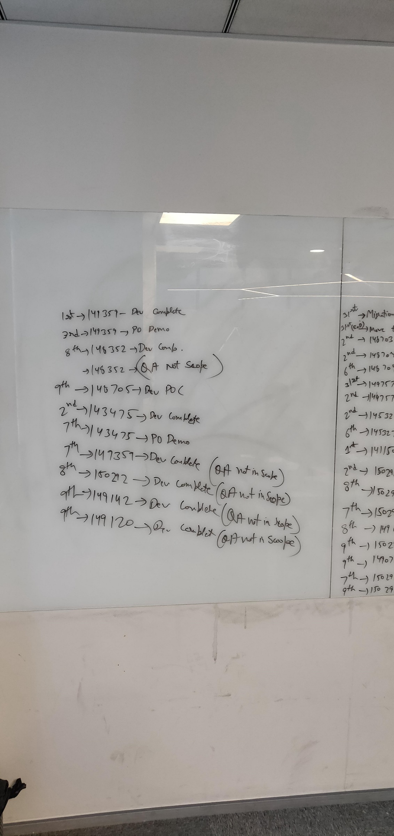

1. **Recall**. If, in Baxter’s sole discretion, or as a consequence of regulatory requirements, Baxter decides to undertake a recall of certain lots of the Product or other fractions processed from the same plasma units as the Product, due to the derivation of the fractions being from the same plasma sourcing or associated with a specific plasma donor whose plasma was used in the manufacture of the Product, Baxter shall notify Kamada of such recall and Kamada shall make the determination of whether or not to initiate a recall of its own products manufactured with the Product from its own customers. If Kamada initiates a withdrawal or recall for any of the reasons specified above or upon proof that the Product used in the manufacture of Kamada’s product caused safety of quality problems in Kamada's product, then Baxter shall reimburse or provide Kamada with the cost of the Product used by Kamada in the production of Kamada’s products or provide equivalent replacement Product. [*****]

1. **Change Control.** Any changes to the Certificate of Analysis will require Kamada’s prior written approval, in accordance with an approval mechanism to be agreed upon under the Quality Agreement. Such approval mechanism will set reasonable and customary notice time frames which will enable Kamada to make all the required arrangements for such change.

1. **Acceptance/Rejection**. Kamada shall have a period of [*****] from date of its receipt of a shipment of the Product and accompanying documentation at Kamada’s Israel plant to inspect and reject all or part of the corresponding shipment of the Product for nonconformity with the Certificate of Analysis, that has not been manufactured, processed, stored, tested, transported internally, disposed of or otherwise handled in accordance with applicable SOPs, cGMPs and/or the Regulations, as such terms are defined in Exhibit B hereto, and in accordance with the Quality Agreement. If Kamada rejects all or part of such shipment, it shall promptly notify Baxter and the provisions of this Article 8 shall apply. In the event that Kamada rejects all or part of any shipment of the Product as above said, Baxter will, at no cost to Kamada, and within [******] replace such nonconforming Product with an equivalent amount of conforming Product depending upon availability of Product.Kamada shall provide Baxter with a proof of destruction notice for all Product rejected by Kamada before any replacement conforming Product is made available to Kamada, depending upon the availability of such replacement product.

Latent Defects. If, after accepting a shipment of the Product, Kamada discovers latent defects that do not conform to the Certificate of Analysis and that are not reasonably discoverable during the [*****] days acceptance period set forth above, Kamada may revoke its acceptance of such shipment of the Product by giving written notice and disclosing the nature of any defects to Baxter as soon as practicable after discovering such defects. In such event, Baxter will conduct further testing to confirm specification nonconformance on the Product. Should Baxter’s test results confirm specification nonconformance, then the Product delivered in such shipment shall be considered a nonconforming Product,and the provisions set forth in this Article 8 shall apply.

[*****] Confidential portions of this document have been redacted and filed separately with the Securities and Exchange Commission.

Page 3

**Term and Termination**. This Agreement shall become effective on the Effective Date and shall remain in full force and effect until December 31, 2021 (the “**Initial Term**”), unless earlier terminated in accordance with the terms herein. The Initial Term may be renewed for two consecutive two (2) year periods (each an “**Additional Term**”) upon mutual agreement of both parties by giving written notice to the other party at least [*****] in advance of the expiration of the Initial Term or any Additional Term. Either party may terminate the Agreement for any reason with twelve (12) months prior written notice to the other party, provided that as a condition to such termination by Baxter, Baxter shall be obligated to provide Kamada, upon Kamada's request, with Products at the amount equivalent to t

1. he previous year's total amount of Products sold to Kamada in addition to the Products to be sold during the last year of the Agreement; such Products, to be sold and delivered under the terms of this Agreement. In the event that either party materially breaches the Agreement, the breaching party upon [*****] days prior written notice shall make a good faith attempt to cure the breach. If the breaching party fails to cure the breach during the [*****] day cure period, the non-breaching party may terminate the Agreement. Articles 3, 4, 5, 6, 7, 8, 9, 10, 14 and 16 shall survive termination of this Agreement. This Agreement shall also be terminated in accordance with the provisions of Article 13 below (Revocation of Product License). Upon termination for any reason, all Products ordered under any purchase orders issued by Kamada prior to such termination shall be supplied to Kamada.

1. **Indemnification**. Kamada shall defend, indemnify and hold harmless Baxter, its successors, assignees, affiliates, directors, officers, agents and employees (collectively referred to in this Article 9 as “**Baxter**”), from and against any and all liabilities, losses, damages and expenses (including reasonable attorney’s fees) actually borne by Baxter as the result of claims, demands, costs or judgments which have been made or instituted against any of them by third parties arising out of Kamada’s purchase, possession, packaging, distribution, use, testing, sale or other disposition of products which were manufactured with the Product, and whether or not resulting from the actual or alleged acts or omissions of Baxter. This indemnity shall not apply, however, to the extent any such liabilities, losses, damages or expenses are caused by the negligence or willful misconduct of Baxter.

Baxter shall defend, indemnify and hold harmless Kamada, its successors, assignees, affiliates, directors, officers, agents and employees (collectively referred to in this Article 9 as “**Kamada**”), from and against any and all liabilities, losses, damages and expenses (including reasonable attorney’s fees) actually borne by Kamada as the result of claims, demands, costs or judgments that may arise out of Baxter’s breach of its warranties under this Agreement or the Quality Agreement or from its negligence or willful misconduct.

[*****] Confidential portions of this document have been redacted and filed separately with the Securities and Exchange Commission.

Page 4

The indemnifying party under this Section 9 (the “**Indemnifier**”) shall have the right to control the defense of any action which is to be indemnified by it hereunder, including the right to select counselreasonably acceptable to the party seeking indemnification (the “**Indemnitee**”) to defend the Indemnitee, and to settle any claim. The Indemnifier will not enter into any settlement that would admit any fault of the Indemnitee or place any blame on the Indemnitee’s products without the prior written consent of the Indemnitee. The provisions of Articles 3, 5 and 9 shall survive and remain in full force and effect after any termination, expiration or cancellation of this Agreement and Kamada’s obligation hereunder shall apply whether or not such claims are rightfully brought.

The Indemnitee shall promptly notify the Indemnifier of any loss, claim, damage, liability or action in respect of which the Indemnitee intends to claim indemnification under this Article 9, and the Indemnifier shall assume the defense thereof at the Indemnifier’s expense. The Indemnitee shall fully cooperate with the Indemnifier and its legal representatives in the investigation and defense (including settlement negotiations) of any matter that is the subject of indemnification. The Indemnitee may elect to be represented by additional counsel of its choosing at its own expense. Both parties shall cooperate fully with each other in the investigation of any action, claim or liability covered by this indemnification.

NOTWITHSTANDING ANYTHING TO THE CONTRARY IN THIS AGREEMENT, NEITHER PARTY SHALL BE LIABLE TO THE OTHER PARTY OR ANY OF ITS AFFILIATES FOR ANY SPECIAL, PUNITIVE, INDIRECT, INCIDENTAL OR CONSEQUENTIAL DAMAGES, INCLUDING WITHOUT LIMITATION LOST PROFITS OR LOST REVENUES.

**10. Insurance:** Kamada shall, to the extent permitted by law, secure and maintain in full force and effect during the term of any clinical trial conducted with Kamada’s product manufactured from the Product and for a period of [*****] following termination of any and all such clinical trials, a Clinical Trials Liability insurance policy in an amount of at least [*****] per occurrence and [*****] in aggregate per annum. A Certificate of Insurance evidencing the appropriate Clinical Trials Liability insurance coverage shall be made available to Baxter within [*****] following Baxter’s request. Upon Kamada’s initial commercial distribution of a final product manufactured by Kamada from the Product supply, Kamada shall, to the extent permitted by law, acquire a Product Liability insurance policy with a coverage limit of [*****] per occurrence and in aggregate per annum. Kamada shall maintain such policy in full force and effect throughout the performance of this Agreement and for a period of [*****] following termination of this Agreement. A Certificate of Insurance evidencing the appropriate Product Liability insurance coverage shall be made available to Baxter within [*****] following Baxter’s request. Baxter shall, to the extent permitted by law, secure and maintain in full force and effect throughout the performance of the Agreement and for a period of [*****] following termination of this Agreement, General Liability Coverage, either by way of an insurance policy and/or self insurance program, in an amount appropriate to assume the risk and provide sufficient coverage for the Product.

[*****] Confidential portions of this document have been redacted and filed separately with the Securities and Exchange Commission.

Page 5

1. **Use of Names.** Neither party shall use the name of the other party or the names of that party’s officers, affiliates, agents or employees in any commercial or noncommercial advertising, article, press release, or any other form of writing without the prior written permission of the party whose name is to be used. Notwithstanding the foregoing: (i) Kamada may disclose the name of Baxter as the manufacturer and supplier of the Product, to the extent required for the transportation and/or importation of such Product to Kamada’s facilities in Israel, and/or as shall be required by any competent regulatory authority, and/or in connection with any due diligence checks by any third party who is bound by customary non-disclosure requirements; and (ii) neither party will be prevented from complying with any duty of disclosure it may have pursuant to applicable laws (including without limitation applicable securities laws or stock exchange regulations), provided however, that such party shall first inform the other party of such request or legal requirement for disclosure.

1. **Force Majeure.** Should Baxter be precluded from supplying all or part of the Product provided for in this Agreement temporarily, indefinitely, or permanently due to acts of God or new legislation such as, riots, strikes, war, act of terror, natural disasters, shortage of plasma due to industry constraints or should Kamada be precluded from further manufacture using all or part of the Product provided for in this Agreement temporarily, indefinitely, or permanently due to acts of God or new legislation such as, riots, strikes, war, act of terror, and natural disasters, then this Agreement shall be suspended to the extent necessary and for the time necessary to allow for the remedy of the situation causing the disruption of sale or use of the Product, provided that the delay in performance shall not exceed [*****] for any reason unless the parties agree in writing to a longer period. If any of the above acts occurs, the affected party will immediately notify the other party by fully disclosing the problem, the date the problem occurred, and the date that production can restart. Notwithstanding the foregoing, the parties agree that a force majeure event does not relieve any party from fulfilling its obligations under sections 2, 4, 5, 7 and 8 of the Agreement. If such circumstances of force majeure continue beyond 3 months (or a longer period agreed on in writing by the parties), the non affected may terminate this Agreement immediately by a written notice to the affected party.

1. **Revocation of Product License.** In the event the establishment and/or maintenance of product licenses under which the Product processed shall be revoked by the respective government regulatory authorities, and therefore, production or sale of the Products is forbidden, this Agreement shall terminate, without penalty to any party, and neither party shall be further liable to the other. Such termination shall be effective immediately upon the affected party notifying the other party in writing of the revocation. Kamada may terminate this Agreement with a [*****] written notice in the event that the establishment and/or maintenance of marketing approval for Kamada’s products derived from the Product shall be revoked by the applicable regulatory authority. In such circumstances, Kamada is obligated to pay for any outstanding Product shipped prior to notice of termination. Without derogating from the above, Baxter shall immediately notify Kamada in writing if it assumes that the establishment and/or maintenance of product licenses under which the Product processed may be revoked.

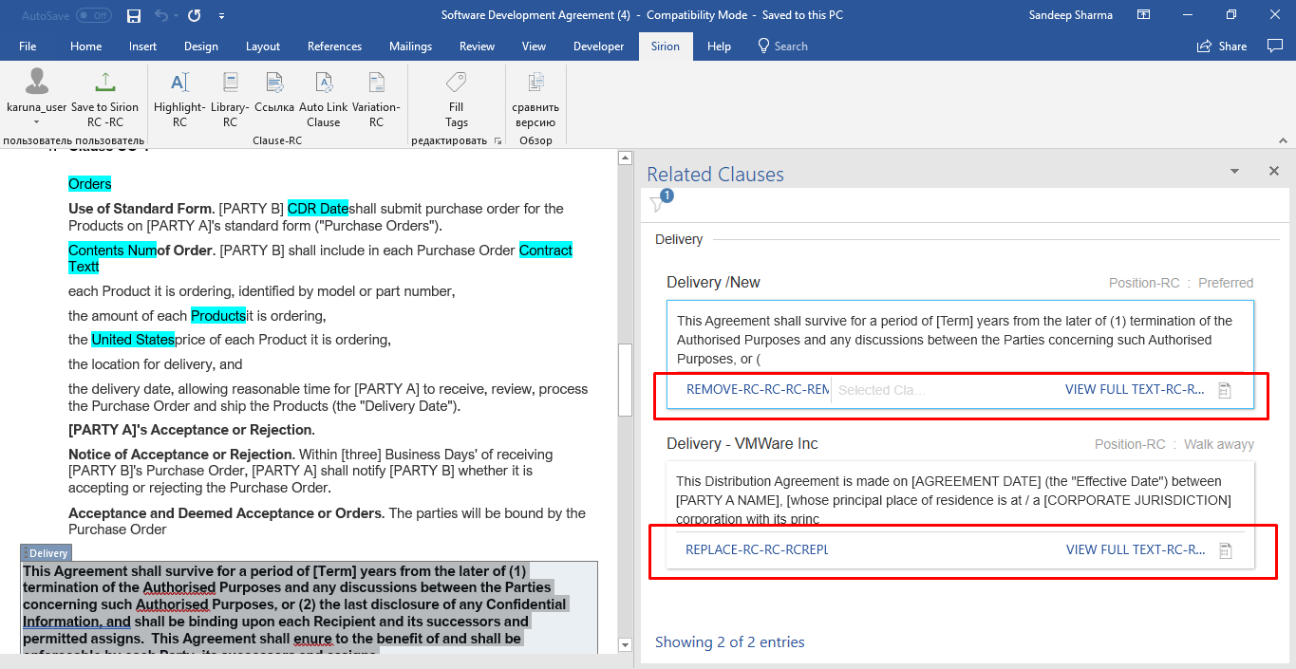

[*****] Confidential portions of this document have been redacted and filed separately with the Securities and Exchange Commission.

Page 6

1. **Notices**. All notices, communications, demands and payments required or permitted to be given or made hereunder or pursuant hereto shall conclusively be presumed for all purposes of this Agreement to be given or made at the time the same is personally given or made, or faxed or emailed, or at the time the same is placed in an envelope and deposited in the mail, with sufficient postage prepaid, addressed as follows:

|  |  |  |
| --- | --- | --- |
| Notice to: |  | Kamada Ltd. |
|  |  | 7 Sapir St. Kiryat Weizmann |
|  |  | Ness-Ziona 74036 |
|  |  | Israel |
|  |  | Attn: David Tsur |
|  |  |  |
| Notice to: |  | Baxter Healthcare S.A. |
|  |  | Postfach, 8010 |
|  |  | Zúrich, Switzerland |
|  |  | Attn: Director, Supply Chain |
|  |  |  |
| With a copy to: |  | Baxter Healthcare Corporation |
|  |  | One Baxter Way |
|  |  | Westlake Village, CA 91362 |
|  |  | Attn: Director, Supply Chain |

1. **Assignment**. This Agreement shall not be assignable by either party, except for an assignment accompanying a transfer of the business to which this Agreement pertains or to a parent corporation or affiliate under common ownership with the transferring party, without the written consent of the other party, which consent shall not be unreasonably withheld.

1. **Governing Law/Arbitration**. This Agreement shall be governed by the laws of England, and its interpretation, construction, and the remedies for its enforcement of breach are to be applied pursuant to and in accordance with the laws of England. The competent courts in London, England shall have exclusive jurisdiction with respect to any and all actions brought hereunder, and each party irrevocably submits to the jurisdiction of such courts.

If a dispute arises between the parties relating to the interpretation or performance of this Agreement, and the parties cannot resolve the dispute within [*****] of a written request by either party to the other party, the parties agree to hold a meeting, attended by individuals with decision-making authority regarding the dispute, to attempt in good faith to negotiate a resolution of the dispute prior to pursuing termination or other available remedies, legal or otherwise.

[*****] Confidential portions of this document have been redacted and filed separately with the Securities and Exchange Commission.

Page 7

1. **Entire Agreement**. This Agreement, the attached Exhibits B and C (Quality Agreement) and the related attachments, constitute the entire agreement between the parties relating to the subject matter herein, and all prior proposals, discussions, letters and agreements by and between the parties and relating to the subject matter herein are hereby superseded and rendered null and void, except for the Confidential Disclosure Agreement dated March 31, 2006. None of the terms of this Agreement shall be deemed to be waived by either party or amended unless such waiver or amendment is written and signed by both parties, and recites specifically that it is a waiver of, or amendment to, the terms of this Agreement.

1. **Severance**. In the event any portion of this Agreement is declared void or invalid by a court or tribunal of competent jurisdiction, such provision shall be modified or severed from this Agreement, and the remaining provisions shall remain in effect, unless the effect of such severance would be to alter substantially this Agreement or the obligations of the parties, in which case this Agreement may be immediately terminated.

Page 8

IN WITNESS THEREOF, the parties have caused this Agreement to be executed by their duly authorized representatives.

**BAXTER HEALTHCARE S.A. KAMADA LTD.**

By: /s/ Sarah Byrne-Quinn By: /s/ David Tsur

Name: Sarah Byrne-Quinn Name: David Tsur

Title: VP Business Development Title: CEO

Date: 18/12/12 Date: 3/12/12

**BAXTER HEALTHCARE S.A. KAMADA LTD.**

By: /s/ Yvo Aebli By: /s/ Gil Efron

Name: Yvo Aebli Name: Gil Efron

Title: Finance Director Title: CFO

Date: 19/12/12 Date: 3/12/12

Page 9

**EXHIBIT A**

**CERTIFICATE OF ANALYSIS:**

# This Exhibit A has been redacted in its entirety.*

* Confidential portions of this document have been redacted and filed separately with the Securities and Exchange Commission.

Page 10

**EXHIBIT B**

**VOLUME / PRICE:**

**Period and**  **Estimated, non-binding,**

**Product manufacturing phase Price Per Kilogram maximum Quantities**

[*****] [*****] [*****] [*****]

The parties shall agree on appropriate mechanisms for Forecasting and Purchase Orders under Section 2 “Orders and Supply”, [*****] days of execution of this Agreement.

The foregoing quantities pertain to Product manufactured through filtration process. Each manufacturing pool consists exclusively of either recovered or source plasma.

Fr. IV-1 Paste samples for each manufactured lot assigned for shipment to Kamada are to be included with each shipment. [*****] aliquots of not less than [*****] each of Fr. IV-1 Paste from each lot are to be collected and transferred to [*****]. The sample test tubes shall be marked with the lot number and shall be placed in bucket A of each lot for each shipment. The samples shall be frozen at no more than –20° Celsius until shipment.

Baxter hereby represents that Fr. IV-1 Paste lots supplied to Kamada under the Agreement are manufactured from the same plasma pools that are used by Baxter in manufacturing of other plasma derivatives for human use.

Beginning [*****] and each [*****] thereafter during the Term, the Product Price shall be [*****] by [*****] over the [*****] as [*****].

**DELIVERY TERMS / LABELING:**

Product to be shipped to the address provided by Kamada as follows:

Delivery of Product - [*****] PASETTISTRASSE (INCOTERMS 2010). Delivery charges are the responsibility of [*****]. Loading and shipping of the Fraction IV-1 Paste must be according to the previously validated procedure “[VN-PVT0062-01-VPR.01]. Loading of the Reefer is done via a cold air lock. Kamada shall define the pallet configuration to meet the conditions at unloading of the Reefer appropriately. The costs for those requirements will be taken by [*****] according to the [*****] delivery conditions.

If Kamada prefers a different shipping method, Baxter will accept Kamada’s validated approach. Costs for thermal protection of the single pallets to meet unloading conditions at the destination appropriately are the responsibility of [*****].

The data loggers (Marathon) will be provided by [*****].

Sending as well as receiving sites will establish SOPs to define the shipping process.

Product to be shipped to the address provided by Kamada as follows:

Efrat Ben Nachum Kamada Ltd.

[*****] Confidential portions of this document have been redacted and filed separately with the Securities and Exchange Commission.

Page 11

Kibutz Beit Kama, M.P. Negev 85325

Israel

Tel Direct: 972-8-9913189

Tel General: 972-8-9913111

Email: efratb@kamada.com

Required Documentation

Original with shipment / copies scanned and sent by e-mail prior, at least [*****] business days prior to shipment:

* Certificate of Analysis for Fraction IV-1 (in the form attached to this Agreement), as shall be amended to comply with the updated regulatory requirements or the competent authorities’ requests, from time to time;
* Packing List stating lots numbers, numbers and weight of each of the buckets in each lot;
* Invoice;
* Certificate of Country of Origin of the Product (Eur 1)

Baxter shall label Product per Attachment 1 of Exhibit B.

**PAYMENT TERMS:**

Baxter shall invoice Kamada upon [*****] of Product from [*****]. Payment shall be due at [*****] of the date of Baxter’s invoice. Invoices paid beyond net terms are subject to a late payment charge of [*****] month.

|  |  |
| --- | --- |
| Kamada to remit payment to: | Baxter Healthcare SA |
|  | Deutsche Bank AG |
|  | Zweigniederlassung Zürich |
|  | Uraniastrasse 9 |
|  | Postfach 7370 |
|  | CH – 8023 Zürich |
|  |  |
|  | [*****] |
|  |  |
| Baxter to bill to: | Kamada Ltd. |
|  | Science Park |
|  | 7 Sapir St. |
|  | Kiryat Weizmann |
|  | Ness-Ziona 74140, Israel |
|  | Attn: Finance Division |

All payments shall be made in euro by way of wire transfer to such bank account that shall be designated from time to time by Baxter.It is agreed that any delay in transfer of any payment hereunder because of telecommunication and other inter-banks issues shall not be considered default by Kamada.

[*****] Confidential portions of this document have been redacted and filed separately with the Securities and Exchange Commission.

Page 12

**Exhibit C**

**REGULATORY SUPPORT**

Upon Kamada’s written request, Baxter will provide Kamada with an authorization letter to reference to the relevant Baxter’s Albumin registration file, as applicable.

Should Kamada wish to file dossier(s) of its AAT or Transfferin to the EMA and/or any local EU Regulatory Authority, either in centralized procedure (CP), decentralized procedure (DCP) or national or MR procedure, Baxter shall provide all the regulatory support and assistance needed for such registration, including preparing and providing Kamada with a [*****], in accordance with the applicable laws, guidelines and regulations [*****]. Baxter shall provide Kamada with the [*****] within [*****] from Kamada's request.

In consideration for Baxter's providing Kamada with such support and assistance, including preparation and provisions of the [*****] ("**Regulatory Support**"), Kamada shall pay Baxter a total amount of [*****] ("**Regulatory Fees**").

Baxter shall, upon written request by Kamada, provide Kamada with pertinent supporting data, information, documentation and/or certifications, including any information derived from additional studies or testing, as may be required under any applicable law and/or by any competent regulatory authority, worldwide, in order to obtain, maintain, or defend the regulatory approvals necessary for the performance of clinical trials with Kamada's products derived from the Product (“**Kamada's Products**”), for the importation of the Product by Kamada and registration of Baxter as authorized supplier with the competent regulatory authorities, the development and/or manufacturing of Kamada's Products and/or for the marketing and sale of Kamada's Products.

In addition, any updates or changes in the above data, information, documentation and certifications shall also be provided as needed.

Obtaining any information or documents that are not generated as part of Baxter's normal business practices (e.g. Product stability data), will be [*****].

**AUDITS**

Kamada has to notify the SUPPLIER about an inspection [*****] in advance. Kamada, in its written notice, will propose the dates and attach an audit plan/agenda ensuring the scope of the audit is properly defined. [*****] shall bear all costs and expenses incurred in connection with the audit. The audit frequency shall be no more than [*****] lasting for no more than [*****],unless there is a serious proven risk signal requiring a specific audit. For any audit request exceeding above described scope SUPPLIER may charge Kamada a reasonable fee, payable in advance.

[*****] Confidential portions of this document have been redacted and filed separately with the Securities and Exchange Commission.

**EXHIBIT D**

# QUALITY AGREEMENT

**ATTACHMENT 1 to Exhibit B: Fraction IV-1 Label:**

